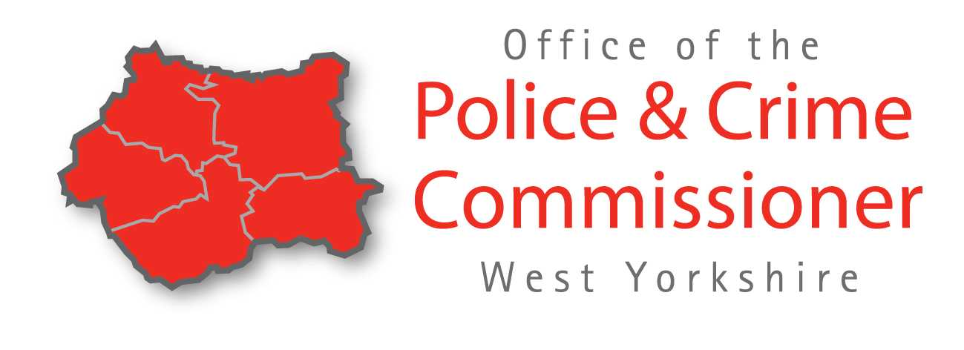
West Yorkshire Police Council Tax Information 2021/2022

Keeping our communitues safe and feeling safe

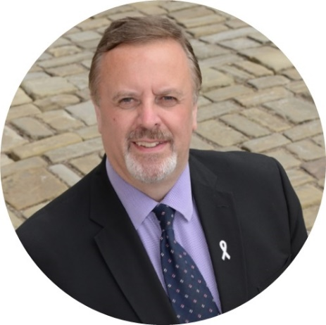
Protecting the people of West Yorkshire has been central to my approach in preparing this latest budget, which both builds upon the foundations we have already laid, whilst taking account of what lies ahead, including the views of the police, our partners and importantly the public during the ongoing impact and challenges posed by Covid-19.

80% of respondents to my public survey on the police precept supported the extra investment proposed which equates to no more than an extra £15 a year for most households, on average around 26p per week given that most properties fall within Bands A to C and will remain the 3rd lowest Police precept in England and Wales.

It will see an additional 251 police officers and 73 police staff recruited and invested into protecting local communities, whilst also sustaining the level of Police Community Support Officers (PCSOs) up to 566 as part of our Neighbourhood Policing Teams throughout West Yorkshire.

Mark Burns-Williamson OBE
West Yorkshire’s Police and Crime Commissioner

Where the money came from 2021/2022

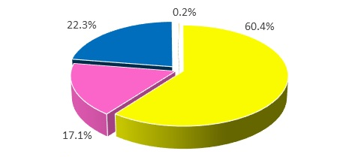
Yellow – Government Grant 60.4%
Pink – Income 17.1%
Blue – Precept (police Council Tax) 22.3%
Orange – Other 0.2%

What the money is spent on 2021/2022
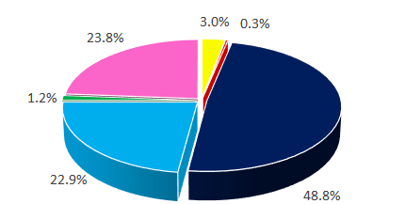
Yellow – PCSOs 3%
Dark Blue – Police Officers 48.8%
Red – Office of the Police and Crime Commissioner 0.3%
Light Blue – Police Staff 22.9%
Green – Borrowing 1.2%
Pink – Running Costs – e.g premises, vehicle 23.8%

Budget | 2020 – 2021  £m | 2021 – 2022  £m
Gross Expenditure | 589.605 | 616.166
Council Tax Requirement | 130.024 | 137.627

Summary: There will be 7.64% increase to the annual police council tax.

Council  Tax Band | Current cost  per year £ | 2021/22  cost £ | Annual  increase £ | Per week  increase £
A | 130.85 | 148.85 | 10.00 | 0.19
B | 152.66 | 164.33 | 11.67 | 0.23
C | 174.47 | 187.80 | 13.33 | 0.26
D | 196.28 | 211.28 | 15.01 | 0.30
E | 239.90 | 258.23 | 18.34 | 0.36
F | 283.51 | 305.18 | 21.67 | 0.43
G | 327.13 | 352.13 | 25.00 | 0.49
H | 392.56 | 422.56 | 30.00 | 0.59
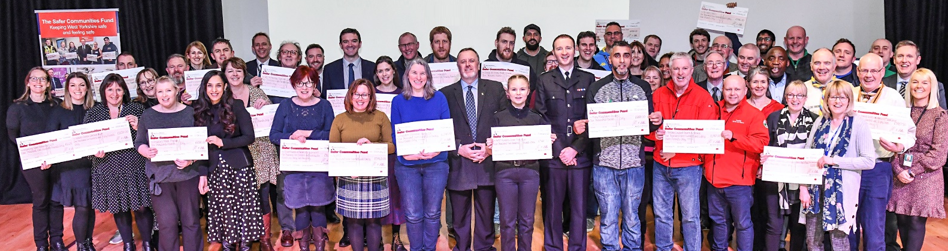

I am delivering for communities across West Yorkshire by:
- Continuing to recruit more police officers and staff, and sustain PCSO numbers by re-building more diverse frontline and neighbourhood policing resilience to protect our communities.
- Commissioning and improving services for victims and witnesses, including working with partners to create the new purpose built Sexual Assault Referral Centre (SARC) facility which opened in 2020.
- Awarding £3.4m of recovered Proceeds of Crime monies to community groups and organisations working to keep communities safe through my Safer Communities Fund (SCF) included a specific grant round to support communities during the pandemic.
- Establishing and continuing to support the Violence Reduction Unit (VRU) which is now into its second year. Its unique public health led approach has begun to help turn the tide on violent crime and its underlying causes.
- Working with key partners to co-ordinate resources to tackle the priorities in the West Yorkshire Police and Crime Plan such as road safety, digital forensics investigations, cyber-crime, child sex/criminal exploitation and domestic abuse, amongst others.
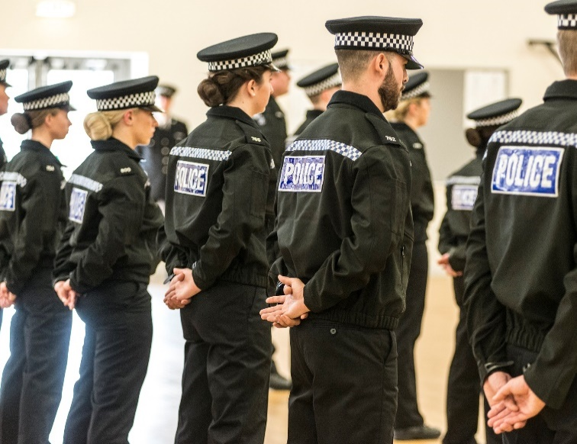

Contact

To find out more or contact Mark:

Telephone: 01924 294000
Email: contact@westyorkshire.pcc.pnn.gov.uk
Website: www.westyorkshire-pcc.gov.uk
Twitter: @WestYorksOPCC
Facebook: @WestYorksOPCC

On 6th May 2021 there is due to be an election for the first ever West Yorkshire Mayor. The West Yorkshire Mayor will have a large remit under the devolution deal agreed, including the transfer of the powers and responsibilities of the West Yorkshire Police and Crime Commissioner (PCC) and the Office of the Police and Crime Commissioner (OPCC) function to the Mayoral Combined Authority. For more information on the upcoming changes ahead of the election, visit our website or contact the office.

